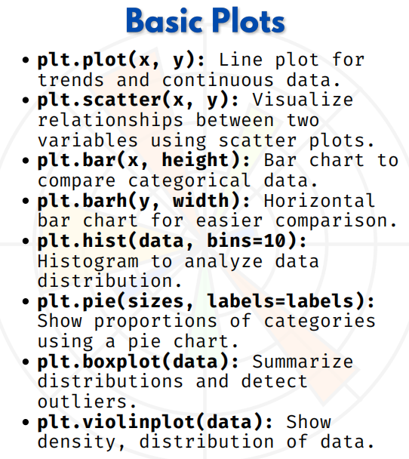

BASIC PLOTs

Matplotlib Basic Plots
1. Line Plot
import matplotlib.pyplot as plt
x = [1, 2, 3, 4, 5]
y = [2, 4, 6, 8, 10]
plt.plot(x, y, marker='o') # line plot with markers
plt.title("Line Plot")
plt.xlabel("X-axis")
plt.ylabel("Y-axis")
plt.show()
Use: Trends, continuous data (time series, growth, etc.)

2. Scatter Plot
x = [5, 7, 8, 7, 6, 9, 5, 6]
y = [99, 86, 87, 88, 100, 86, 103, 87]
plt.scatter(x, y, color='red')
plt.title("Scatter Plot")
plt.xlabel("X values")
plt.ylabel("Y values")
plt.show()
Use: Relationship between two variables (e.g., height vs weight)
3. Bar Chart
categories = ['A', 'B', 'C', 'D']
values = [4, 7, 2, 9]
plt.bar(categories, values, color='skyblue')
plt.title("Bar Chart")
plt.show()
Use: Compare categorical data.

4. Horizontal Bar Chart
categories = ['A', 'B', 'C', 'D']
values = [4, 7, 2, 9]
plt.barh(categories, values, color='orange')
plt.title("Horizontal Bar Chart")
plt.show()
Use: When category labels are long.

5. Histogram
import numpy as np
data = np.random.randn(1000) # 1000 random numbers
plt.hist(data, bins=20, color='purple', edgecolor='black')
plt.title("Histogram")
plt.show()
Use: Distribution of continuous data.

6. Pie Chart
sizes = [30, 20, 25, 25]
labels = ['Apples', 'Bananas', 'Cherries', 'Dates']
plt.pie(sizes, labels=labels, autopct='%1.1f%%', startangle=140)
plt.title("Pie Chart")
plt.show()
Use: Show proportions (market share, expenses, etc.)

7. Box Plot
data = [7, 8, 5, 6, 7, 8, 5, 10, 12, 6, 8, 7]
plt.boxplot(data)
plt.title("Box Plot")
plt.show()
Use: Summarize data distribution, detect outliers.

8. Violin Plot
import numpy as np
data = [np.random.normal(0, std, 100) for std in range(1, 4)]
plt.violinplot(data, showmeans=True)
plt.title("Violin Plot")
plt.show()
Use: Shows both distribution + density (better than box plot sometimes).

